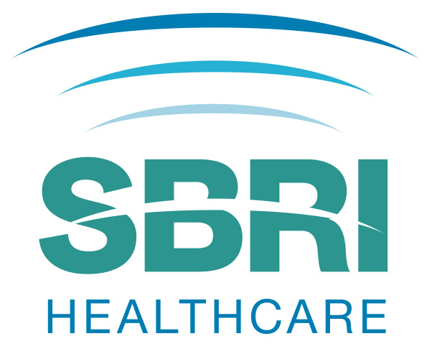

SBRI Healthcare: NHS England competition for development contracts

INVITATION TO TENDER
This Invitation to Tender should be read in conjunction with other documents associated with this competition. These and all associated documents can be downloaded from the SBRI Healthcare website www.sbrihealthcare.co.uk.

Summary
Applicants are invited to tender for projects under the SBRI Healthcare programme to develop technology enabled solutions addressing the challenges outlined in the following category, further details of which are outlined in the competition brief:
- Cancer – Screening, Earlier Diagnosis & Faster Diagnosis

Application Process
All bids should be made using the SBRI Healthcare portal which can be accessed by following the application links via the competition pages of the SBRI Healthcare website www.sbrihealthcare.co.uk.
Details of the background, challenges and expected outcomes of the projects can be found in the Brief. You are strongly advised to read the Guidance Notes before submitting an application.
SBRI Healthcare competitions are open to all organisations that can demonstrate a route to market for their solution. The SBRI Healthcare scheme is particularly suited to small and medium-sized business, as the contracts are of relatively small value and operate on short timescales. Developments are 100% funded and focused on specific identified needs, increasing the chance of exploitation. Suppliers for each project will be selected by an open competition process and retain the intellectual property generated from the project, with certain rights of use retained by the NHS. This is an excellent opportunity to establish an early customer for a new technology and to fund its development.
The competition will have two phases. Phase 1 is intended to show the technical feasibility of the proposed concept. The development contracts awarded will be for a maximum of 6 months and £100,000 (inc. VAT) per project.
Phase 2 contracts are intended to develop and evaluate prototypes or demonstration units from the more promising technologies in Phase 1. Only those projects that have completed Phase 1 successfully will be eligible for Phase 2. The development contracts awarded in Phase 2 will be for a maximum of 12 months and £1,000,000 (inc. VAT) per project.

Applicants should state their goals and outline plan for Phase 2, as an explicit part of the path to full commercial implementation, in their Phase 1 proposal.
Briefing events for businesses interested in finding out more about the competition will be held on 25 July (London), 26 July (Leeds), 26 July (Nottingham) and 27 July (Manchester). Please check the website for confirmation of venues and further details.
Applications must be submitted via the SBRI Healthcare portal which can be accessed by following the application links via the competition pages of the SBRI Healthcare website www.sbrihealthcare.co.uk. The form must be completed and submitted electronically through the online application portal. Only applications received by 1200hrs on 6 September 2017 will be accepted. We strongly advise that you read the accompanying Guidance Notes prior to submission.
PLEASE DO NOT SEND COMPLETED APPLICATIONS BY POST OR BY ANY OTHER MEANS THAN THROUGH THE PORTAL AS DESCRIBED ABOVE.

Key dates
Competition launch | 25 July 2017
Deadline for applications | Noon, 6 September 2017
Assessment | September / November 2017
Contracts awarded | End November 2017
Feedback provided by | December 2017

Assessment process
Applications will be reviewed by a selected panel of experts. It may be that a number of finalists will be requested to attend an interview or provide a demonstration for the panel. Contracts will be awarded shortly thereafter. Feedback to unsuccessful applicants will be given after contracts are awarded.
The assessment criteria will include:
- How well does the proposal address the challenge?
- To what extent does the proposed project have commercial potential to lead to a marketable product, process or service?
- How significant is the competitive advantage which this technology affords over existing/alternate technologies that can meet the market needs?
- How appropriate is the technical approach that will be adopted?
- How sound is the approach of the proposed plan for establishing technical and commercial feasibility?
- Where appropriate, what is the potential of the innovation to support comorbidities and contribute to the development of patient-centred care?
- What is innovative about this project? To what extent does the project develop or employ novel concepts, approaches, methodologies, tools, or technologies for this area?
- To what extent does the company appear to have the right skills and experience to deliver the intended benefits?
- How effectively will the project be managed? The proposal should demonstrate that there is a clear management plan which will enable the resources, including manpower, to be used to maximise high quality research outputs.
- What are the risks (technical, commercial and environmental) to project success? How effectively will these be managed?
- How appropriate is the proposal financially? Is the overall budget realistic and justified in terms of the aims and methods proposed?
- How appropriate are the milestones and evaluation procedures?

Successful applicants will be advised according to the published key dates and companies will be expected to mobilise rapidly to start the project. It is important that Phase 1 Projects start soon after the contract has been issued so that all projects can be assessed fairly and move on to Phase 2 concurrently and smoothly.

Conditions
By applying, companies are automatically consenting to the terms and conditions contained in the Contract.

Documents associated with this competition
- SBRI_13_Invitation to Tender
- SBRI_Portal_Guidance
- Sample Application Form
- SBRI_Sample Contract
- SBRI_13_FAQs
- SBRI_13_Cancer Briefing Doc

Contact Points
Questions and comments are very welcome while the competition is open. Questions on the challenges and scope of this SBRI Healthcare competition should be addressed to Health Enterprise East via email: sbrienquiries@hee.co.uk; questions on the overall SBRI programme should be addressed to support@innovateuk.gov.uk. Questions will only be accepted when received through this route. After 4th September 2017, no new questions will be answered. In order to streamline the process for this competition, feedback to unsuccessful suppliers may not be available until after the contracts have been awarded. Such feedback will be provided by Health Enterprise East, the programme administrator, on behalf of the Contracting Authority.
For further information on this SBRI Healthcare competition, visit:
www.sbrihealthcare.co.uk
For more information about the SBRI programme, visit: https://www.gov.uk/government/collections/sbri-the-small-business-research-initiative

